**Methods**

In order to check for selective reporting and make sure that what we are observing is not simply the result of publication bias and p-hacking, we carried out *p*-curve analyses based on Simonsohn, Nelso, and Simmons (2014). According to Simonsohn et al. (2014), a *p*-curve presents visually the distribution of the *p* values that are statistically significant for a set of studies (*p*s <. 05), and when the effect truly exists, for example, if we set the significance level to 0.05, then we should expect to see more low *p* values (0.1s) than *p* values that although are smaller than 0.05, but very close to it (0.04s).Therefore, we can conclude that there is no need to worry about publication bias only when the *p*-curve is right-skewed, indicating a majority of low *p*s in the set of studies that are included in our meta-analysis.

The *p*-curve analysis was conducted not only for effect sizes of all the studies that are in our meta-analysis, but was also carried out separately for the agentic and communal constructs. This is inspired by one of the reviewers, who has proposed that it is possible that publication bias may be observed for the agentic constructs, in that they are the focal constructs in most published studies on narcissistic self-enhancement.

The *p*-curve analyses were realized via the online APP 3.0 (<http://www.p-curve.com/app3/>) developed by Simonsohn, Nelson, and Simmons.

**Results:**

In order to meet the independence assumption of *p*-curve analysis, composite effect sizes instead of original effect sizes were used. A total of 36 composite effect sizes were entered to the online APP along with the sample size. For example, the first composite effect size comes from a sample of 145 participants, and the effect size, which is the correlation between narcissism and self-enhancement, equals -0.13. Therefore, we entered r (145) = -.13 in the box on the APP website, along with all other 35 results in the same format.

Out of the 36 composite effect sizes, 13 of them were excluded from *p*-curve because they were not statistically significant at the significance level of 0.05. The remaining 23 significant results were included in the *p*-curve.

In Figure 1 the distribution of the *p* values of all significant results are demonstrated, presenting a curve of *p* values that is statistically significantly right-skewed. Therefore, we can conclude that there is indeed evidential value in the set of studies that are included in our meta-analysis, and the effect sizes we have are not the results of publication bias or selective reporting.

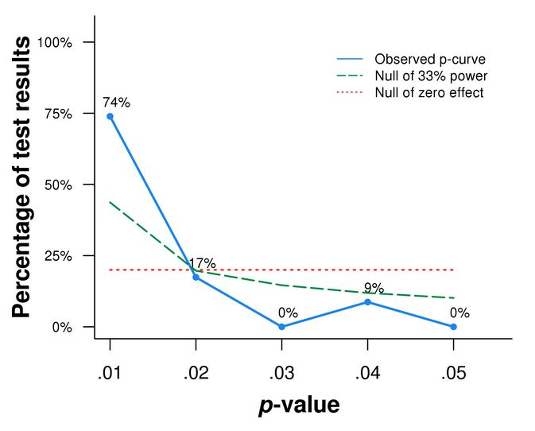

*Figure 1*. *P*-curve containing *p* values of all statistically significant effect sizes (α= 0.05). N= 23 *p* values. 74% of all the significant results have *p* values smaller or equal to 0.01, and 91% no larger than 0.02. The curve is significantly right-skewed based on both the binomial test (which tests the share of significant results *p* <.025; *p* < 0.0001) and the continuous test (Z = -12.78, *p* < .0001).

To conclude, the *p*-curve analysis with a statistically significant right-skewed p-curve has shown that most studies in our meta-analysis contain evidential values, and therefore, it doesn’t seem like we need to worry about publication bias or *p*-hacking.